**AHMAD IRFAN**

**23L-6052**

**BEE-3C**

**Electronic Devices and Circuits (EE1004)**

**Assignment-1 (PBL)**

**Report on DC Power Supply Noise Issues and Solutions**

**Introduction** As part of the lab maintenance team in the Electrical Engineering department at FAST-NUCES Lahore, it has been observed that some of the DC power supplies (model: MPS-3005L-3) in the electronics lab are malfunctioning, producing unstable and noisy output signals. This noise disrupts the accuracy of experiments and affects the performance of sensitive circuits dependent on clean, stable power. This report aims to investigate the possible causes of this noise, explain its impact on the output signal, outline the methods used to detect the noise, and propose solutions to eliminate it, ensuring reliable power supply performance.

**Possible Sources of Noise and Their Impact on Output Signal**

**Internal Noise Sources:**

1. **Switching Noise:** Modern DC power supplies like the MPS-3005L-3 regulate voltage through high-speed internal switching circuits. This switching action can introduce high-frequency noise, resulting in minor voltage fluctuations that compromise the stability of the output.
2. **Aging Components:** Over time, certain components within the power supply—such as capacitors, resistors, and transistors—may degrade. Aged capacitors may lose their filtering efficiency, allowing unwanted electrical noise to pass through to the output.
3. **Thermal Noise:** When components operate at high temperatures, especially during prolonged usage, the random motion of electrons generates thermal noise. Overheating of critical parts within the power supply can degrade performance and cause additional noise.

**External Noise Sources:**

1. **Electromagnetic Interference (EMI):** Nearby equipment such as motors, transformers, or other electronics can emit electromagnetic waves. These signals may couple with the power supply, creating interference that degrades the output quality.
2. **Power Line Disturbances:** Irregularities in the incoming AC supply, such as voltage surges, spikes, or harmonics, can propagate through the power supply and introduce noise to the output.

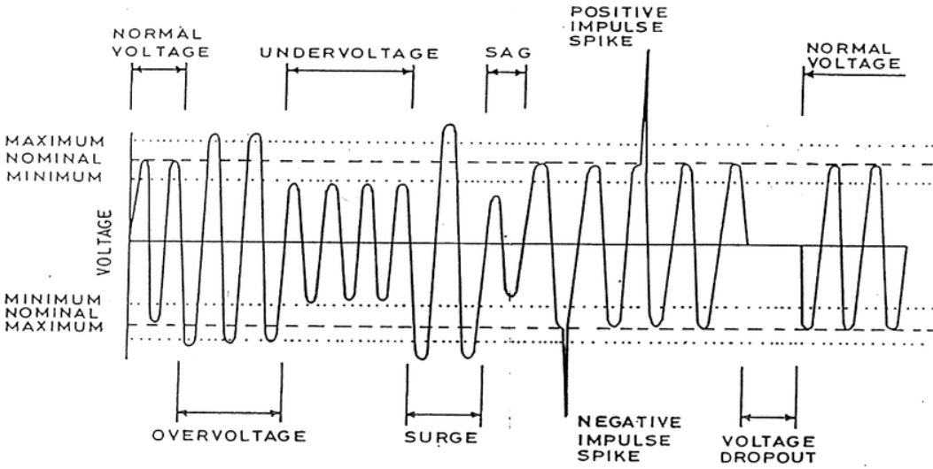

Figure power line disturbances

1. **Ground Loops:** Improper grounding or having multiple grounding points can create a ground loop, allowing stray currents (the current flowing through paths other than the intended electrical circuit) to flow and cause low-frequency noise, which disrupts the smooth output of the power supply.

**Impact of Noise on Output Signal:** The presence of noise in the DC output results in voltage instability, which can have serious consequences on circuits that rely on steady, clean power. Voltage fluctuations can lead to inaccurate measurements, malfunctioning equipment, or even damage to sensitive components such as sensors, amplifiers, or microcontrollers. For applications requiring precision, noisy power can result in corrupted data or unstable system performance.

**Methodology for Detecting Noise in Output Signals**

Detecting noise in a DC power supply requires a combination of basic inspection techniques and advanced diagnostic tools:

1. **Visual Inspection:**
   * **Monitor Built-in Display:** Many modern power supplies, such as the MPS-3005L-3, come equipped with digital displays that show real-time voltage and current readings. By carefully observing these displays, any sudden or unexplained fluctuations may signal the presence of noise or instability in the output.

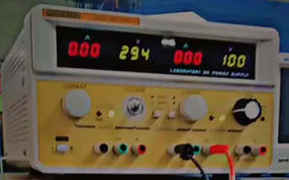

Figure DC SOURCE

1. **Oscilloscope Testing:**
   * **Waveform Analysis:** Connecting the power supply output to an oscilloscope provides a clear visual of the signal. Ripples, spikes, or irregularities in the waveform indicate the presence of noise.

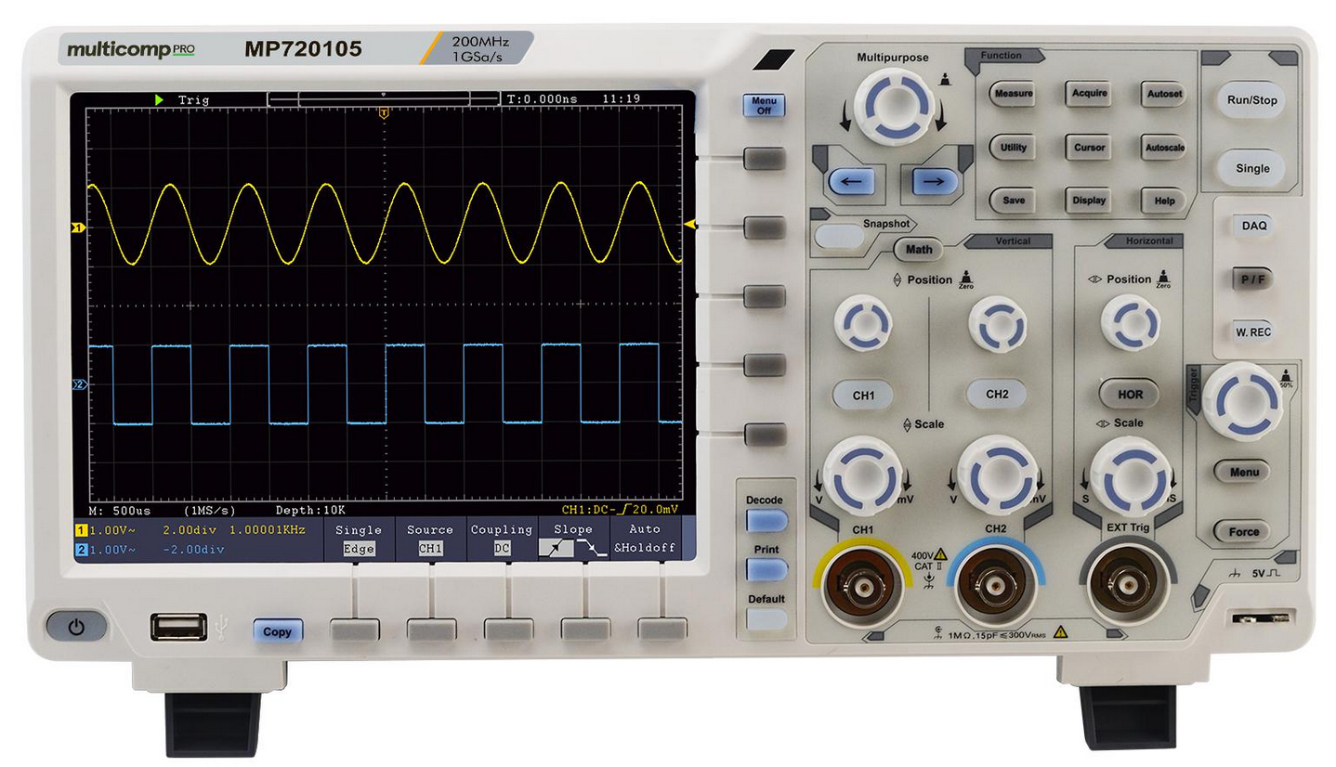

Figure Oscilloscope

1. **Advanced Diagnostic Tools:**
   * **High-Resolution Oscilloscope:** Using an oscilloscope with finer time resolution enables the detection of high-frequency noise that may not be visible with standard instruments.

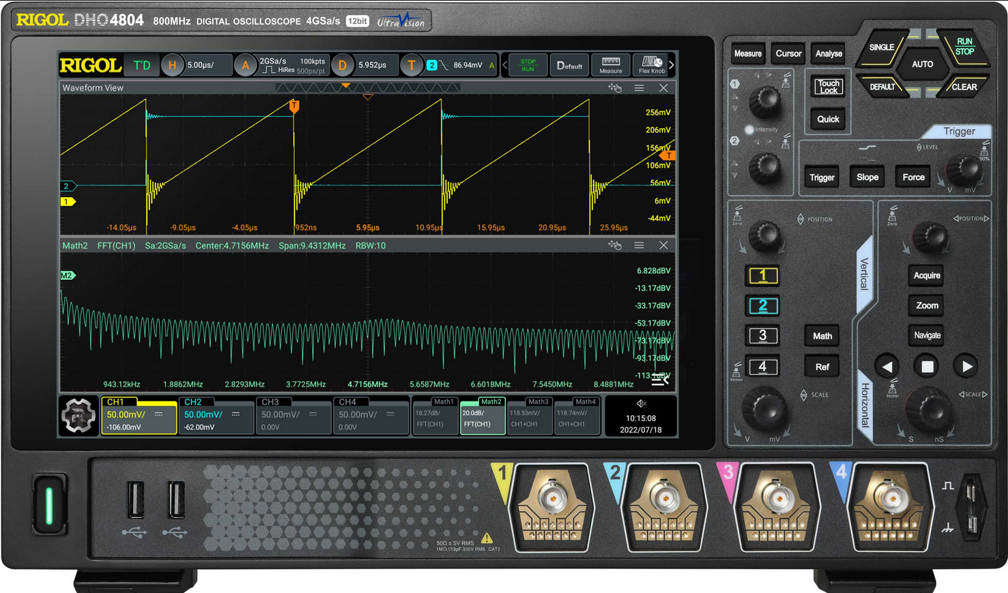

Figure High-Resolution Oscilloscope

* + **Spectrum Analyzer:** For more precise identification, a spectrum analyzer can be used to isolate the specific frequencies where the noise is occurring, which can be especially useful for diagnosing EMI-related issues.

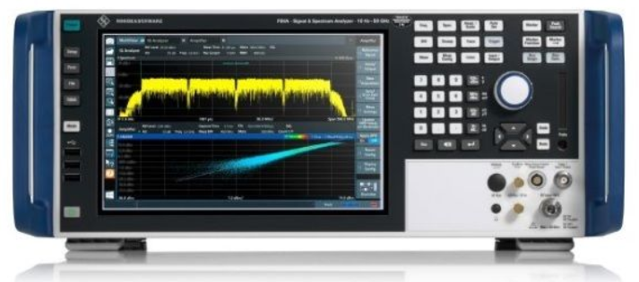

Figure Spectrum Analyzer

* + **Thermal Imaging:** Using a thermal camera to monitor the temperature of internal components can help detect any component that are overheating and potentially generating noise.

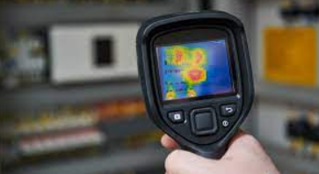

Figure Thermal Imaging device

**Why It Is Necessary to Remove Noise**

Removing noise from the power supply is critical for several reasons:

1. **Accurate Measurements:** Many lab experiments and designs depend on precise voltage levels. Noise can cause measurement errors, which in turn lead to incorrect results and flawed experiments.
2. **Protection of Components:** Sensitive electronics are vulnerable to voltage spikes or fluctuations. Noise can accelerate the wear and tear of components or even damage them irreversibly.
3. **Signal Integrity:** For digital systems or communication circuits, maintaining clean, stable signals is essential. Noise can cause signal degradation, leading to data corruption or communication failures.
4. **System Reliability:** Noisy power supplies may cause circuits to behave unpredictably, leading to system malfunctions, breakdowns, or even safety hazards.

**Techniques for Reducing Noise**

**Internal Solutions:**

1. **Component Replacement:** Aging capacitors, resistors, and other components should be regularly inspected and replaced as needed. Worn-out capacitors should be replaced to restore proper filtering and stabilize the output.
2. **Improved Ventilation and Cooling:** Ensuring adequate ventilation for the power supply helps maintain optimal operating temperatures, minimizing thermal noise. If overheating is detected, installing cooling fans or replacing damaged components can mitigate noise.

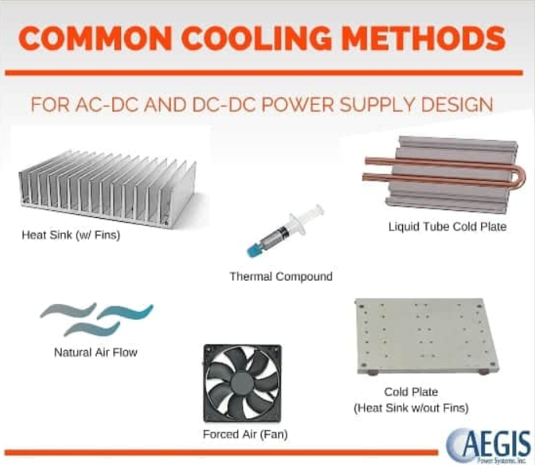

Figure Improved Ventilation and Cooling

1. **Low-Pass Filters:** Installing low-pass filters inside the power supply can help block high-frequency noise, allowing only the stable, low-frequency DC signal to reach the output.

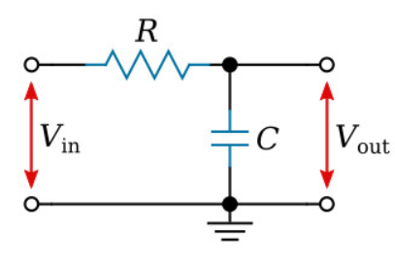

Figure RC circuit

**External Solutions:**

1. **EMI Shielding:** Implementing proper electromagnetic shielding around the power supply can protect it from external interference sources, particularly in environments with heavy EMI exposure.

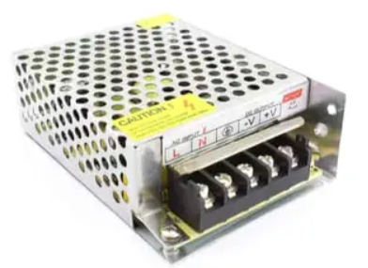

Figure EMI Shielding

1. **Proper Grounding:** Ensuring that the power supply is grounded correctly, and avoiding multiple ground points, can help eliminate ground loops and reduce low-frequency noise.
2. **Ferrite Beads:** Adding ferrite beads to the output wires can effectively suppress high-frequency noise, further improving the quality of the power supply’s output signal.

Figure Ferrite Beads

**Additional Techniques:**

1. **Bypass Capacitors:** Placing small-value capacitors (ranging from 10nF to 100nF) across the output terminals can filter out high-frequency noise and ensure a cleaner DC signal.
2. **Active Noise Cancellation:** For more complex systems, active noise cancellation techniques can be applied. This method involves detecting the noise and applying an opposite signal to cancel it out, resulting in a cleaner output.

**Conclusion**

In conclusion, the noise issues identified in the MPS-3005L-3 DC power supplies in the FAST-NUCES Lahore Electronics lab are detrimental to the accuracy and reliability of experiments and circuits. By addressing both internal and external sources of noise, employing proper detection methods, and implementing solutions such as component replacement, improved cooling, EMI shielding, and proper grounding, we can significantly reduce noise levels. Ensuring regular maintenance and monitoring of the power supplies will prevent future occurrences of noise and maintain reliable, clean outputs for all lab applications.

**References:**

1. Sharma, R. (2020). *Understanding Noise in DC Power Supplies*. Power Electronics Insights.
2. Ali, S. (2018). *Techniques for Reducing Electromagnetic Interference*. Journal of Electrical Engineering.
3. Khan, M. (2021). *Analyzing Switching Noise in Power Supplies*. Electrical Design Review.